**HOW TO UPLOAD APK ON PLAY STORE**

1. Go to the android Studio
2. Open the Project on android studio.
3. Go to build => Go to generate Signed bundle/APK => Mark the app and press next button .
4. Set the key store path (path should save on the android/app.
5. Set keystore password , alias passwor and tab on next button .
6. When the apk is generated

=> Go to play store (<https://play.google.com/console/u/0/developers>)

1.Create the account .

2.After created go to login section and login the account .

3.Dashboard => Go to Create app on right corner .

4.Create app

1. Add the app detail .

2. After created that will move to Dashbord .

1. Go to section of Set up your app

Fill all the section and of the set up your app

Createria required .

1. Short description :(1-80 character )
2. Long Description (0-4000 characters)
3. App Icon Graphic (Transparent PNG or JPEG ,512 px by 512 px , Up to 1 MB)
4. Feature graphic Image ( PNG or JPEG, 1,024 px by 500 px,Up to 1 MB)
5. Video( Youtube link but it’s optional )
6. Phone screenshots *(Upload 2–8 phone screenshots , ,PNG or JPEG , 16:9 or 9:16 aspect ratio , Each side between 320 px and 3,840 px, Up to 8 MB per screenshot )

=> GO to Publish your app on Google Play

1. Add the country where you want to upload .
2. Create production release
3. Upload apk

According to google 2018 some feature will change . 64 bit procedure is required

​​[**APKs or App Bundles are available to 64-bit devices but they only have 32-bit native co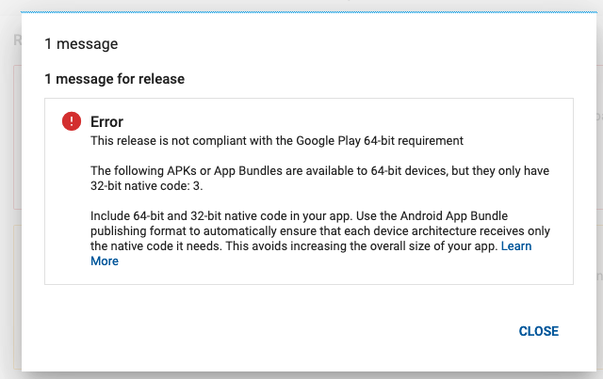de**](https://stackoverflow.com/questions/57561855/apks-or-app-bundles-are-available-to-64-bit-devices-but-they-only-have-32-bit-na)

How to resolve this error .

Go to the android/app/gragle

Defaultconfig{

* - -

ndk.abiFilters 'armeabi-v7a','arm64-v8a','x86','x86_64'

}

**splits {**

**abi {**

**reset()**

**enable enableSeparateBuildPerCPUArchitecture**

**universalApk true // If true, also generate a universal APK**

**include "armeabi-v7a", "x86", "arm64-v8a", "x86_64"**

**}**

**}**

2. Go to android.gradle.build

buildscript {

ext {

buildToolsVersion = "29.0.2"

minSdkVersion = 20

compileSdkVersion = 29

targetSdkVersion = 29

supportLibVersion = "28.0.0"

googlePlayServicesAuthVersion = "17.0.0"

googlePlayServicesVersion = "17.0.0"

androidMapsUtilsVersion = "0.6.2"

}

**3. Go to terminal**

**$ cd android && ./gradlew clean**

**$ cd android && ./gradlew bundleassamble**

**$ cd android && ./gradlew releaseassamble**

**4. Go to android studio**

1. **Go to buld => signed apk release**
2. **Choose apk and press next button .**
3. **Create the apk . after creating the apk upload in the play store .**

**Problem resolve .**

**Keep enjoy**

**Thank You**

**Sumit kumar**